LAB Practical
Name:K.Srinath
Reg No: 192524220
Code:CSA5112
Course:Cryptography And Network Security

1. Implement the simple substitution technique named Caesar cipher using C language.
Aim: To implement the Caesar Cipher substitution technique using C language.
Algorithm :
1.Read the plaintext.
2.Read the key (shift value).
3.Shift each alphabet by the key value.
4.If the shift exceeds 'Z', wrap around to 'A'.
5.Display the ciphertext.
6.Stop.
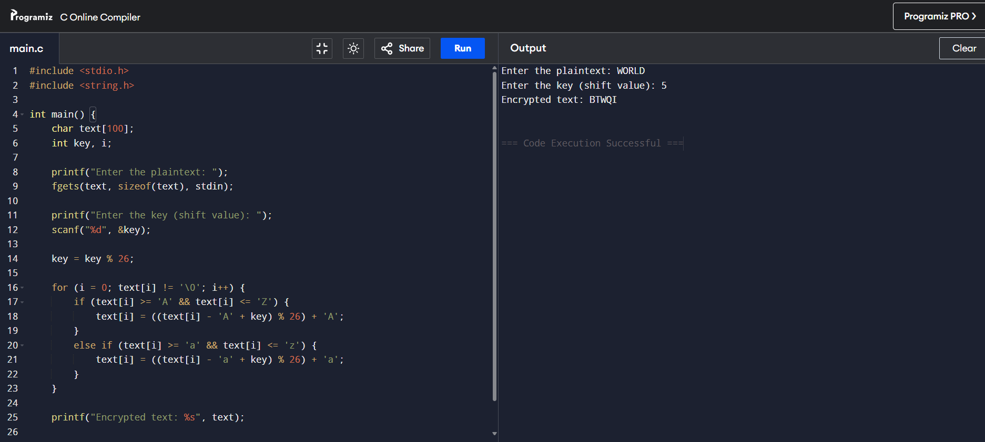

2. Write a C program to implement the Playfair Substitution technique.
Aim : To implement the Playfair Cipher substitution technique using C language.
Algorithm
- Start.
- Read the keyword and plaintext.
- Generate the 5 × 5 Playfair matrix.
- Divide the plaintext into pairs.
- Encrypt each pair using Playfair rules:
  - Same row → Replace with the next letter.
  - Same column → Replace with the letter below.
  - Rectangle → Replace with letters at opposite corners.
- Display the ciphertext.
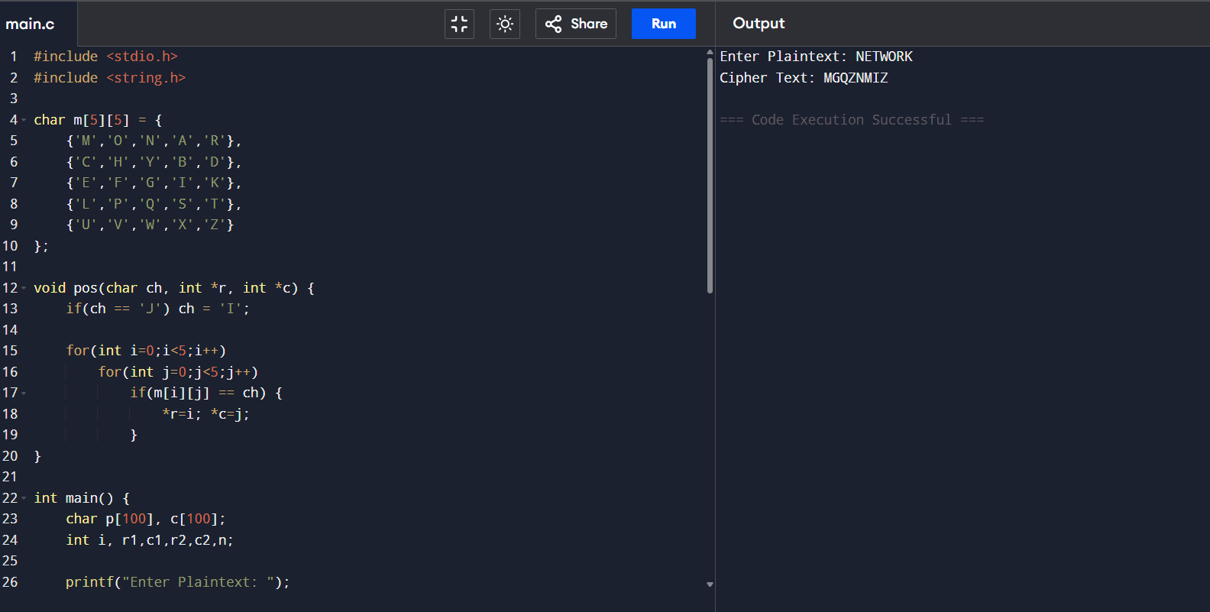
- Stop.

3.Write a C program to implement the hill cipher substitution techniques.
Aim
To implement the Hill Cipher substitution technique using C language.
Algorithm
- Start.
- Read the plaintext.
- Read the key matrix.
- Convert letters into numerical values (A = 0, B = 1, ..., Z = 25).
- Multiply the plaintext vector by the key matrix.
- Take modulo 26 of the result.
- Convert numbers back into letters.
- Display the ciphertext.
- Stop.

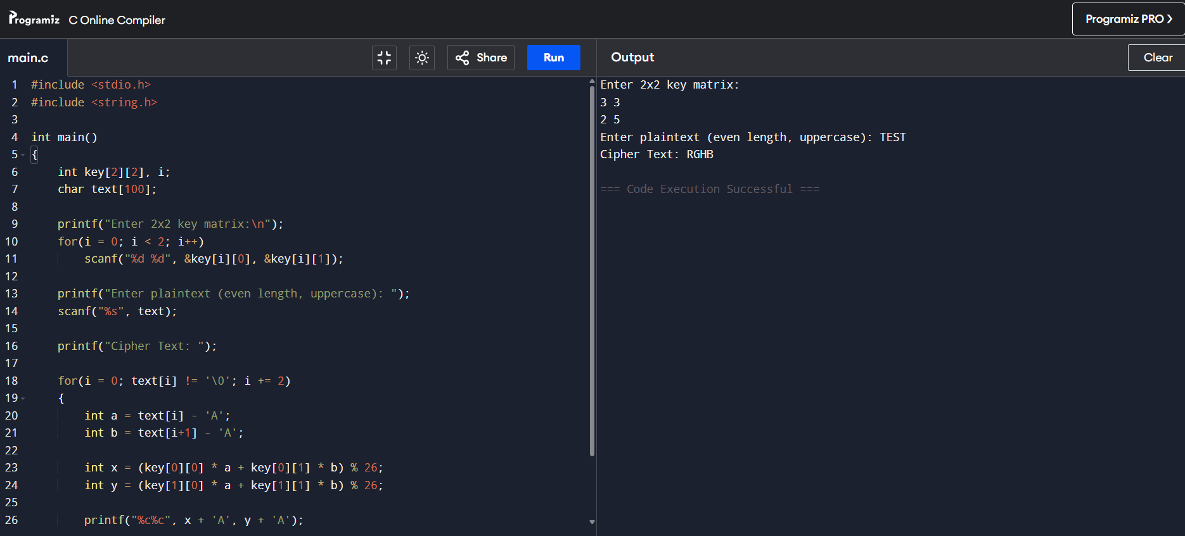

4.Implement the Vigenere Cipher substitution technique using C program.
Aim
To implement the Vigenère Cipher substitution technique using C language.
Algorithm
- Start.
- Read the plaintext.
- Read the keyword.
- Repeat the keyword until it matches the plaintext length.
- Encrypt each letter using the Vigenère formula.
- Display the ciphertext.
- Stop.

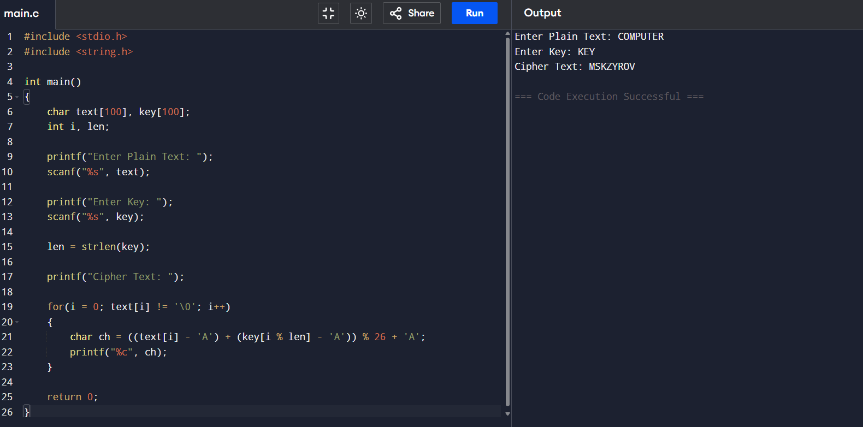

5.Write a C program to implement the rail fence transposition technique.
Aim
To implement the Rail Fence Transposition Cipher using C language.
Algorithm
- Start.
- Read the plaintext.
- Arrange the plaintext in rails.
- Read the characters row by row.
- Display the ciphertext.
- Stop.

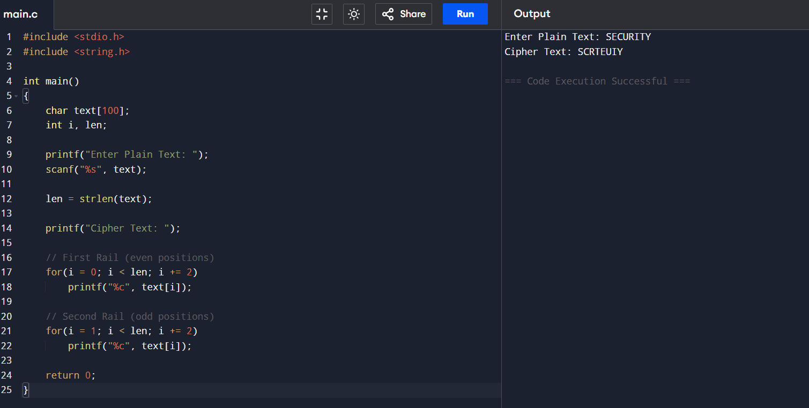

6.Write a C-Program to implement the Mono Alphabetic substitution technique.
Aim
To implement the Monoalphabetic Substitution Cipher using C language.
Algorithm
- Start.
- Read the plaintext.
- Use a predefined substitution alphabet (key).
- Replace each plaintext letter with its corresponding substituted letter.
- Display the ciphertext.
- Stop.

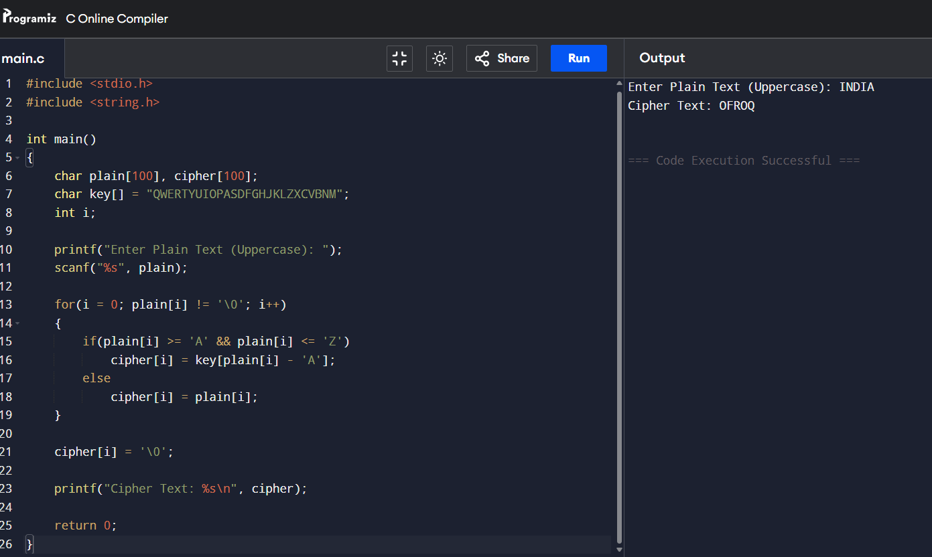

7.Write a C-Program to implement Row column transposition technique.
Aim
To implement the Row-Column Transposition Cipher using C language.
Algorithm
- Start.
- Read the plaintext.
- Read the number of columns.
- Fill the plaintext into a matrix row-wise.
- Add padding characters if necessary.
- Read the matrix column-wise.
- Display the ciphertext.
- Stop.

